**Digital Signal Processing Final Examination**

25th Dec. 2019

**Name: ____ZHANG Yangsong___________ No: ______516021910119____________**

**Instructions:**

1. Receive the paper-version of exam sheets and write your name and student number on the sheet.
2. Find the of the answer-sheet file in specified fold named ‘DSP2019’.
3. Write your results of each question in answer sheet, with the student number in the figure title as ‘No. XXXXXXX’.
4. Include all your codes in the appendix.
5. When the examination is finished, Let examiner to collect your paper-version of exam sheets and copy the answer sheet file.
6. Test time: 180 minutes

**Problem 1 (50%)**

A periodic signal *x*(*t*), is shown in Figure 1, where the fundamental period *xp*(*t*) is a half sine, defined as



The parameters are shown in Table 1.

Table 1 Parameters of the half sine period

*x*(*t*)

*t*

*A*

*B/*2

*-B/*2

…

…

*D/*2

*-D/*2

Figure 1 A periodic signal

*xp*(*t*)

|  |  |  |  |
| --- | --- | --- | --- |
| Parameters | *A* | *B* | *D* |
| Values | 1.5 | 4 | 1 |

* 1. (a) Indicate the fundamental radian frequency . (b) Numerically estimate the Fourier series coefficients *X*(*k*) with *k* =-3, -2, -1, 0, 1, 2, 3, according to Eq. (2), fill *X*(*k*) in the table. (c) Calculate the ratio between the power of the fundamental frequency component and the average power *P* as defined in Eq. (3). (14%)





W0=2*pi/B=0.5*pi

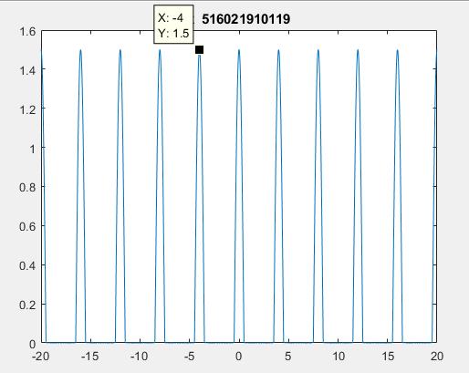

Figure 1 plot of x

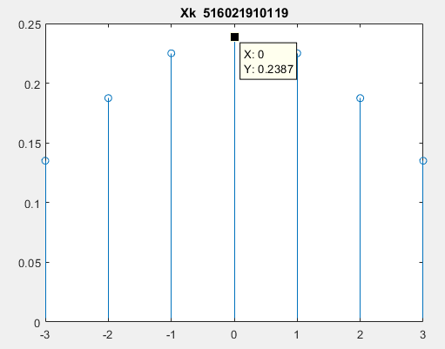

Figure 2 plot of Xk

|  |  |  |  |  |  |  |  |
| --- | --- | --- | --- | --- | --- | --- | --- |
| K | -3 | -2 | -1 | 0 | 1 | 2 | 3 |
| value | 0.1351 | 0.1875 | 0.2251 | 0.2387 | 0.2251 | 0.1875 | 0.1351 |

Table 1 value of Xk

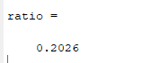

Figure 3 ratio

* 1. Truncate *x*(*t*) with a uniform window as , where w(t) is in Eq. (4), and calculate the Fourier Transform . (a) Plot the truncated signal *y*(*t*). (b) Plot the modulus and phase of  in degrees in the frequency region . (12%)



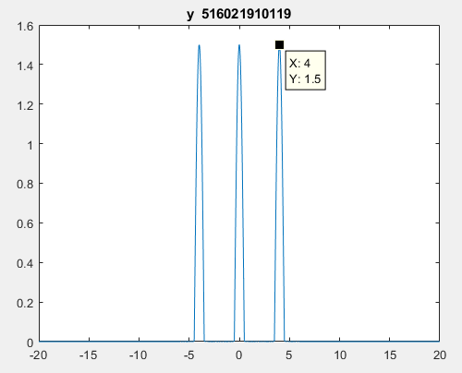

Figure 4 plot of y

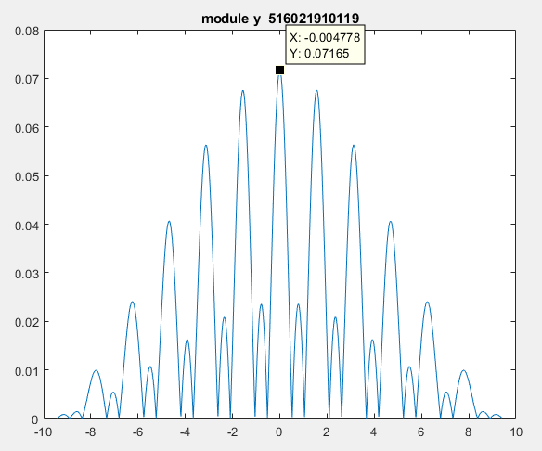

Figure 5 modulus of Y

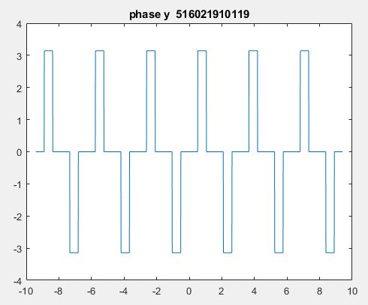

Figure 6 phase of Y

* 1. Sample *y*(*t*) with the time interval *T*= 0.1, denoted the samples as *y*1(*nT*). (a) Compare *y*(*t*) and *y*1(*nT*) in a figure.

(b) Calculate Fourier Transform of *y*1(*nT*) in the frequency region . Compare the modulus of  and  in a figure. (c) Tell the differences between  and  in the Nyquist interval. (15%)

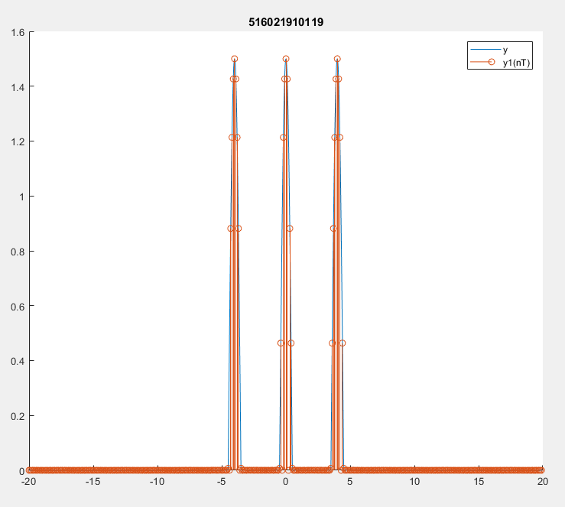

Figure 7 comparison of y and y1

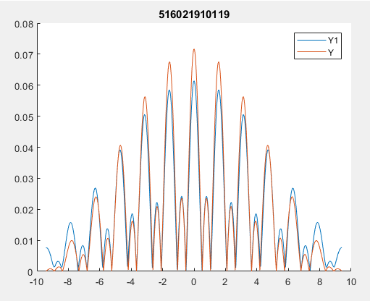

Figure 8 comparison of Y and Y1

Y1 is smaller than Y.

* 1. Calculate discrete Fourier Transform of *y*1[*n*] in , denoted as . Compare the modulus of  and . (9%)

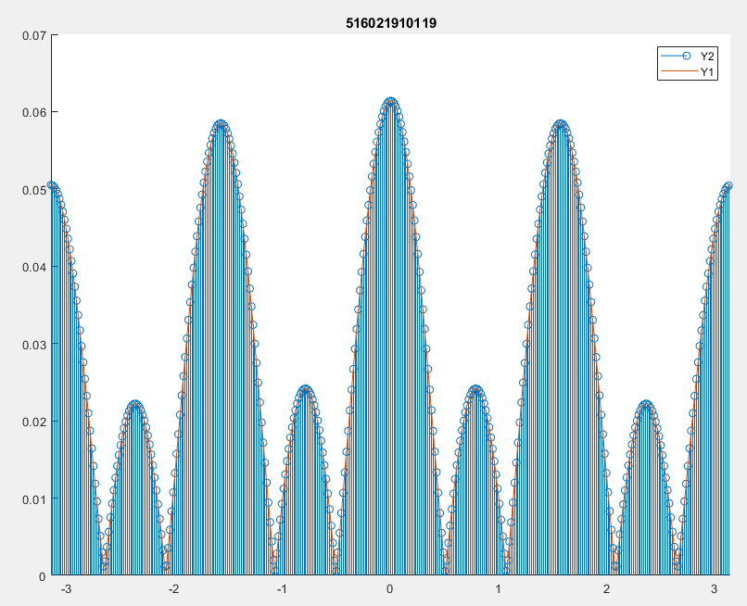

Figure 9 comparison of Y1 and Y2